

INTERVIEW – THE CEO MAGAZINE

BARBARA BORRA – President and CEO Franke Home Solutions

BIO
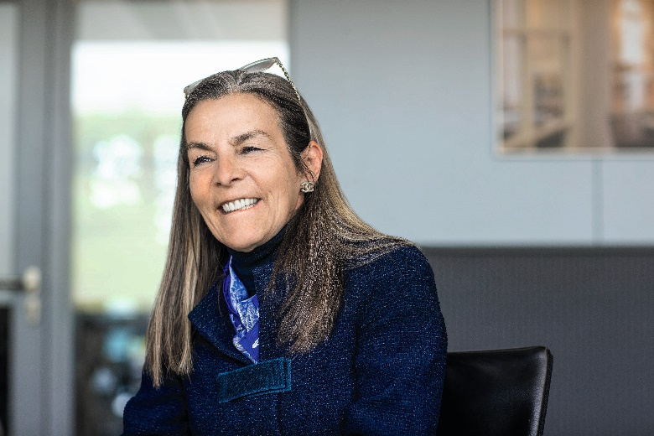
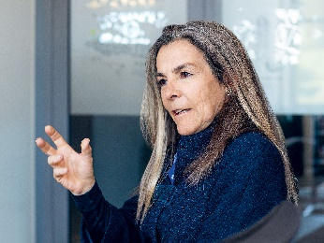
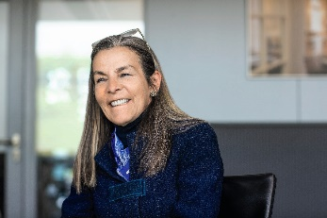
Barbara Borra joined Franke Group in 2019 as President and CEO of Franke Kitchen Systems and member of the Management Board. Her entry into the company has marked the beginning of a journey aimed at optimizing all processes in the division. Since January 2021, she leads Franke Home Solutions, the new division of the Swiss multinational born out of the merger between Franke Kitchen Systems and Faber Hoods & Cooking Systems, which aims to create synergies and expand its presence in the kitchen environment by leveraging the experience gained by the division.
A graduate of the Polytechnic University of Turin in Chemical Engineering, she later obtained a Master Degree in Business Administration from INSEAD in Fontainebleau. She started her career at Montedison, a well-known Italian group operating mainly in the chemical sector. In 1989, she took an important international role within the General Electric Group, where she worked for over ten years, until becoming Vice President of Marketing for EMEA and India for the Lighting Division. Her debut in the white goods industry happened when she joined Whirlpool, where she held positions of global responsibility, until she was appointed Vice President and General Manager China Operations in 2011. Since 2015 she is also an Independent Board Member of Randstad and, in 2021, she was also appointed as independent Director of Fluidra, the global leader in equipment and connected solutions in the pool and wellness sector.

